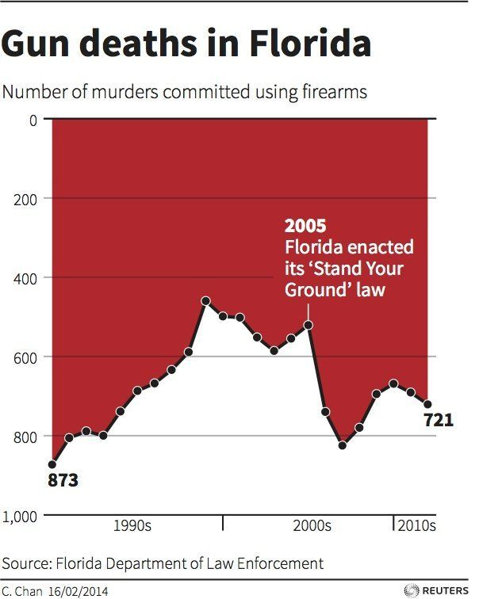

Link: <https://www.businessinsider.com/gun-deaths-in-florida-increased-with-stand-your-ground-2014-2>

**Why it is lying and how this can be fixed (if it is lying)?**

Witch the use of line and dark red area with inverted y-axis, the chart accidentally implies other meanings of the chart. The misleading meaning hear would be the number of murder is suddenly decrease after Florida enacted its ‘Stand Your Ground’ law. This could be fixed by not using the inverted y-axis which would flip the graph horizontally.

**Data-ink ratio and whether and how to improve it?**

The chart use red area too much and the data-ink ratio could be reduce by remove the red ink and use the black line only.

**Whether any chartjunk should be removed?**

For simplicity, the grey line which represent the number of murder scale (e.g. 200, 400, 600, 800) could be removed. However, this is optional since removing the grey line might have low data-ink.

**Storytelling: Describe the context in which the visualisation is used and identify the storytelling genre?**

Context source: <https://www.livescience.com/45083-misleading-gun-death-chart.html>

- In 2005, Florida established their new self-defence law which called ‘Stand Your Ground’ which allow people to use gun for self-protection. This leads to a high death rate using gun which could be shown in the chart above.

- The storytelling genre would be annotated chart